**ALVA’S P .U COLLEGE, MOODBIDRI**

Department of Chemistry

**CET / NEET crash course 2019 – 2020**

**Topic:** **Biomolecules and II PUC practicals.**

1. Number of stereo centers present in linear and cyclic structures of glucose are respectively:

1) 4 & 4 2) 4 & 5 3) 5 &4 4) 5 &5

**Ans:**  **2**



1. Which of the following statements is not true about sucrose?

1) The Glycosidic linkage is present between C1 of α-Glucose and C1 of β-fructose.

2) It is also named as invert sugar

3) It is a non reducing sugar

4) On hydrolysis, it produces glucose and fructose

**Ans : 1,Glycosidic linkage is between C1 ofα-Glucose and C2 of β-fructose.**

1. The term anomers of glucose refers to

1) Isomers of glucose that differ in configurations at carbons one and four (C-1 and C-4)

2) A mixture of (D)-glucose and (L)-glucose

3) Enantiomers of glucose

4)  Isomers of glucose that differ in configuration at carbon one (C-1)

**Ans : 4.**

1. Thiol group is present in

1) Cystine 2) Cysteine 3) Methionine 4) Cytosine

**Ans : 2.**



1. The correct sequence of amino acids present in the tripeptide given is:

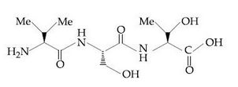

1) Val-Ser-Thr 2) Thr- Ser-Val 3) Leu-Ser-Thr 4) Thr-Ser-Leu

**Ans :1.**

1. The dipeptide, Gln-Gly, on treatment with CH3COCl followed by aqueous work up gives:

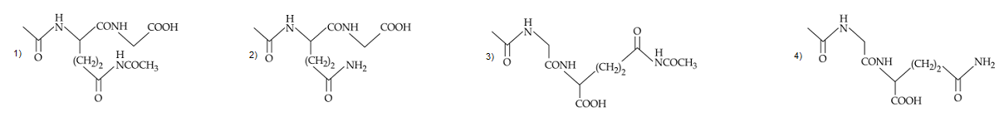

**Ans : 2; The dipeptide, Gln-Gly, on treatment with CH3COCl followed by aqueous work up gives the product shown in option (2). Amino group of glutamine is acetylated. Amide group of glutamine is not acetylated.**

**Note: Acetylation of amide requires activation of amides and/or acyl donors, since the nitrogen atom**

**of amides is less basic than that of the corresponding amines due to amide resonance.**

1. Adenosine is an example of

1) Purine base 2) Nucleoside 3) Nucleotide 4) Pyrimidine base

**Ans : 2.**

1. Two samples of DNA, A and B have melting points 340 K and 350 K respectively. This is because

1) B has more GC content than A 2) A has more GC content than B

3) B has more AT content than A 4) Both have same AT content.

**Ans : 1; Since GC base pair having three H- bonds and AT base pair having two H-bonds, therefore,**

**DNA, B has higher melting point than DNA, A.**

1. Vitamin C is a/an

1) lactone 2) amine 3) amide 4) alcohol

**Ans : 1.**

1. The dipeptide glycylalanine contains

1) glycine as C-terminal residue 2) glycine as N-terminal residue

3) alanine as N-terminal residue 4) either (1) or (2)

**Ans : 2; By convention, the name of any polypeptide is written starting from the N-terminal residue.**

1. Vitamin B12 is present in

1) Meat 2) Fish 3) Egg 4) Curd

**Ans : 4.**

1. The correct statement regarding RNA and DNA respectively is

1) The sugar component in RNA is arabinose and the sugar component in DNA is ribose.

2) The sugar component in RNA is 2′-deoxyribose and the sugar component in DNA is arabinose.

3) The sugar component in RNA is arabinose and the sugar component in DNA is 2′-deoxyribose.

4) The sugar component in RNA is ribose and the sugar component in DNA is 2′- deoxyribose.

**Ans : 4.**

1. In an amino acid, the carboxyl group ionizes at pKa1 = 2.34 and ammonium ion at pKa2 = 9.60. The isoelectric point of the amino acid is at pH

1) 5.97 2) 2.34 3) 9.60 4) 6.97

**Ans : 1**

**Isoelectric point (pI) =(pKa1 + pKa2) /2**

**= (2.34 + 9.60)/2 = 5.97**

1. Which of the following statements about denaturation given below are correct

I. Denaturation of proteins causes loss of secondary and tertiary structure of the protein.

II. Denaturation leads to the conversion of double strands of DNA into single strand.

III. Denaturation affects primary structure which gets distorted.

1) II and III 2) I and III 3) I and II 4) I, II and III

**Ans : 3**

1. Consider the following sequence of reactions

The final product (Z) is

1) Sorbital 2) Fructose 3) Mannose 4) Mannitol

**Ans: 2**

** **

**where R = HOCH2(CHOH)3-**

1. the product (X) of the above reaction is

1) L-glucose 2) D-fructose 3) D-iolose 4) D-talose

**Ans : 2**

Lobry de Bruyn van Ekenstein rearrangement.

1. Which of the following does not exhibit the phenomenon of mutarotation?

1) (-) fructose 2) (+) sucrose 3) (+) lactose 4) (+) maltose

**Ans : 2; Sucrose due to the absence of hemiacetal linkage doesn’t show mutarotation.**

1. The glycosidic linkage involved in linking the glucose units in amylose part of starch is

1) C1-C4 β linkage 2) C1-C6 α linkage  3) C1-C4 α linkage  4) C1-C6 β linkage

**Ans : 3.**

1. **Assertion:** Valine is an essential amino acid.

**Reason:** The lack of essential amino acids in the diet causes Kwashiorkor .

1) Assertion is correct, reason is correct reason is a correct explanation for assertion.

2) Assertion is correct, reason is correct; reason is not a correct explanation for assertion.

3) Assertion is correct, reason is incorrect.

4) Assertion is incorrect, reason is correct.

**Ans : 2; Essential amino acid are those which the human body cannot synthesize.**

1. Match the columns

**Column – I Column – I**

A.Vitamin B6 I. Fat soluble

B. Vitamin K II. Xerophthalmia

C. Vitamin D III. Convulsions

D. Vitamin A IV. Delayed blood Clotting

1) A- I,II; B-I, IV; C-I, D-III 2) A-III; B-I,IV; C-I; D-I,II

3) A-I,IV; B- III; C-I; D-I,II 4) A-III; B-I,IV; C-I,II; D-I

**Ans: 2**

1. In E. coli DNA, AT/GC ratio is 0.93. If the number of moles of adenine in the DNA sample is 465,000, then the moles of guanine present is

1)465,000 2) 535,000 3)500,000 4)93,000

**Ans : 3; Since the number of moles of adenine(A) must be equal to that of thymine(T), therefore,**

**A+ T=465,000 +465,000 = 930,000**

**Further since (A+ T)/(G+C)=0.93, therefore,(G+C)= 930,000/0.93 = 1000000**

**Further since the number of moles of C = number of moles of G.**

**∴Number of moles of guanine (G) = 1000,000 /2 = 500,000**

1. If the sequence of bases in DNA is TGAACCCTT then the sequence of bases in m-RNA is

1) ACUUGGGAA 2) TCUUGGGTT 3) ACUUCCCAA 4) None of the above

**Ans : 1; Sequence of bases in DNA: TGAACCCTT**

**Since according to base-pairing principle, T in DNA faces A in m-RNA, while G faces C and A faces U. Therefore, sequence of bases in m-RNA is: ACUUGGGAA.**

1. The correct structure of histidine in a strongly acidic solution (pH = 2)

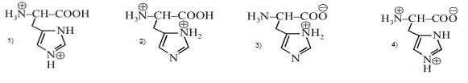

**Ans: 1**



1. Which of the vitamins given below is water soluble?

1) vitamin E 2) vitamin K 3) vitamin C 4) vitaminD

**Ans : 3**

1. Pick the wrong statement from the following

1) Consumption of citrus fruit and green leafy vegetable in food prevents scurvy.

2) Deficiency of Vitamin B6 results in Convulsions.

3) Sources of vitamin B1 are yeast, milk, green vegetables and cereals.

4) Deficiency of vitamin D causes xerophthalmia.

**Ans: 4, Deficiency of vit. D causes rickets.**

1. The deficiency of vitamin K caues

1) Haemorrhage 2) Lengthening time of blood clotting

3) Inflammation of tongue 4) Both (1) and (2)

**Ans: 4**

1. Glucose reacts with X number of molecules of phenyl hydrazine to yield osazone. The value of X is

1)Three 2) Two 3) One 4) Four

**Ans: 1**



glucose glucosazone

1. The peptide that gives positive ceric ammonium nitrate and carbylamines tests is:

1) Ser – Lys 2) Asp – Glu 3) Glu – Asp 4) Lys – Asp

**Ans: 1; Serine has –OH group which gives positive ceric ammonium nitate test. Lysine has –NH2**

**group which gives positive carbylamines test.**

1. The incorrect statement among the following is

1) α-D-glucose and β-D-glucose are anomers.

2) α-D-glucose and β-D-glucose are enantiomers.

3) Cellulose is a straight chain polysaccharide made up of only β-D-glucose units.

4) The penta acetate of glucose does not react with hydroxyl amine.

**Ans:2**

1. Which of the following is the sweetest sugar?

1)  Sucrose 2) Glucose 3) Fructose 4) Maltose

**Ans : 3**

1. For  (peptide bond)

1) C-N bond length in proteins is longer than the usual bond length of the C-N bond

2) Spectroscopic analysis shows planar structure of the  group

3) C-N bond length in proteins is smaller than the usual bond length of the C-N bond

4) None of the above

**Ans: 3**

**Due to resonance C-N bond in protein acquires double bond character and thus it is smaller than the**

**usual C-N bond.**



1. Which of the following reactions of glucose can be explained only by its cyclic structure?

1) Glucose forms a cyanohydrin with HCN

2) Glucose reacts with hydroxylamine to form an oxime

3) Pentaacetate of glucose does not react with hydroxylamine

4) Glucose is oxidized by nitric acid to gluconic acid.

**Ans: 3**

1. The correct corresponding order of names of four aldoses with configuration given below:



l) L- erythrose, L-threose, L- erythrose, D-threose.

2) D- threose, D- erythrose, L- threose, L- erythrose.

3) L-erythrose, L-threose, D- erythrose, D- threose.

4) D-erythrose, D-threose, L-erythrose, L- threose

**Ans: 4**

1. The “N” Which does not contribute to the basicity for the compound is:



1) N7 2) N9 3) N1 4) N3

**Ans: 2**



**The lone pair of N9 participate in resonance with the compound hence cannot gain proton.**

1. The correct structure of product ‘P’in the following reactions is:



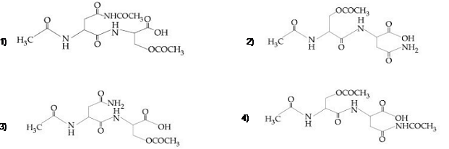

**Ans : 3**

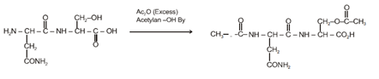

1. The non-essential amino acid among the following is:

1) Valine 2) Leucine 3) Alanine 4) Lysine

**Ans: 3**

1. In both DNA and RNA, heterocyclic base and phosphate ester linkages are at

1) C5’ andC1’ respectively of the sugar molecule

2) C1’ and C5’ respectively of the sugar molecule

3) C2’ and C5’ respectively of the sugar molecule

4) C5’ and C2’ respectively of the sugar molecule

**Ans: 2**

**In both DNA and RNA, heterocyclic base and phosphate ester linkages are at C1’and C5’respectively of**

**the sugar molecule.**

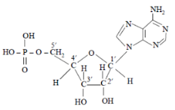

1. The structural feature which distinguishes proline from natural α-amino acids?

1) Proline is optically inactive 2) Proline contains aromatic group

3) Proline is a dicarboxylic acid 4) Proline is a secondary amine

**Ans : 4**

1. The equivalent mass of KMnO4 in alkaline medium is its

1) 2) 3) 4) molar mass itself

**Ans : 2**

**2 + H2O → 2 + 2OH- + 3[O]**

**Equivalent mass = $\frac{molar mass}{3}$**

1. The purpose of adding dilute sulphuric acid in the preparation of Mohr salt is

1) To prevent the hydrolysis of ferrous sulphate 2) To increase the solubility of the salt used

3) To prevent the precipitation of carbonates of metals 4) To neutralize ammonium salts.

**Ans : 1**

1. Chromyl chloride vapours are dissolved in water and acetic acid and lead acetate solution is added, then

1) The solution will remain colourless 2) The solution will become dark green

3) A yellow solution will be obtained 4) A yellow precipitate will be obtained

**Ans : 4**

**CrO2Cl2 + 2H2O → H2CrO4 + 2HCl**

**Yellow solution**

**H2CrO4 + (CH3COO)2Pb → PbCrO4 + 2CH3COOH**

**Yellow ppt.**

1. If NaOH is added to an aqueous solution of zinc ions a white precipitate appears and on adding excess NaOH, the precipitate dissolves. In this solution zinc exists in the

1) Cationic part 2) Anionic part

3) Both in cationic and anionic parts 4) There is no zinc ion in the solution

**Ans : 2,; Zn2+ + 2NaOH → Zn(OH)2 + 2Na+**

**Zn(OH)2 + 2NaOH → Na2ZnO2 + 2H2O**

1. The salt insoluble in cold water but soluble in boiling water is

1) CaCl2 2) BaCl2 3) SrCl2 4) PbCl2

**Ans : 4**

1. Mg is not precipitated in V group because

1) MgCO3 is soluble in water 2) MgCO3 is soluble in NH4Cl

3) MgCO3 is soluble in NH4OH 4) none

**Ans : 2**

**The concentration of ${CO}_{3}^{2-}$ ions is very low which does not allow the ionic product of Mg2+ and**

**ions to exceed the solubility product in presence of NH4Cl**

1. Upon treatment with ammoniacal H2S, the metal ion that precipitates as a sulphide is

1) Fe (III) 2) Al (III) 3) Mg (II) 4) Zn (II)

**Ans : 4; Ammoniacal H2S is a group reagent for fourth group basic radicals. Fe (III), Al (III), Mg (II) precipitates as hydroxides.**